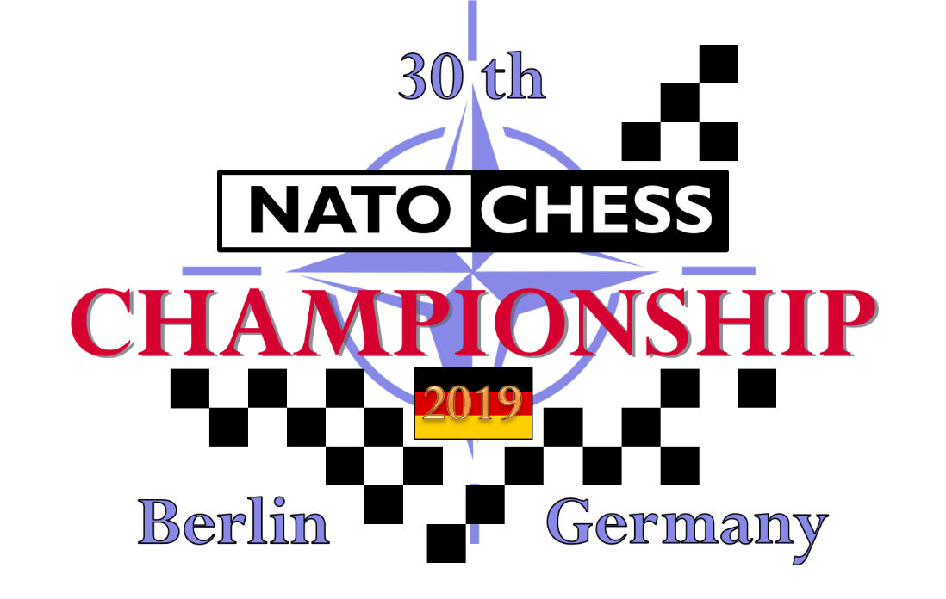
INFORMATION BULLETIN

General
- The German Ministry of Defence invites every NATO member to send a chess team to the 30th NATO chess championship 2019. The event will be organised by the catholic working group for soldier care (KAS e.V.)
- The tournament will be held at Julius-Leber-Barracks in the heart of Germany’s capital Berlin.
Address:
Kurt-Schumacher-Damm 41
13405 Berlin
- Entry to Julius-Leber-Barracks requires a photographic ID; this can be in form of a passport, civil or military ID card.
- The tournament will take place from 16th to 20th September 2019. Teams should arrive on Sunday, 15th September, 06:00 pm at the latest and depart on Saturday, 21st September in the morning.
- The entry fee for every participating person and spouse is 330 € each.
- Early arrivals and late departures will cause additional cost for accommodation (15 € per night per person without any food)
- The competition format is a seven round individual swiss with team competition. A player may not be paired against a player from the same nation. The competition will be run under the rules of FIDE as agreed by the International Military Chess Committee (IMCC).
- Nations may send teams of up to 6 players, plus a team captain and a team official. Players must be members of their Nations Armed Forces or permanently employed by their Ministry of Defence. All players must have a FIDE ID. Lifetime members may play with the approval of the IMCC and organising committee.

Informal and Formal agreement
- Please return the filled informal agreement not later than 15th March 2019. After a first estimate we will inform you quickly if it is possible to send extra players. But do keep in mind that according to the IMCC rules No. 2.5 you need an IMCC approval.
- We expect the formal agreement not later than 1st July 2019. Furthermore we kindly ask for your complete travel information. If they are not available yet we are willing to accept them shortly before the beginning of the tournament.

Payment
- Bank details for transfer are given below, it is preferred that teams make one single payment using the reference “NATO2019 XXX” where the three letters “XXX” indicate the nation paying (CAN/FRA/ITA/POL/USA etc.).
Where individuals make a payment this should include the surname after the nation indicator.
Bank account owner: Catholic working group for soldier care
IBAN: DE96 3706 0193 0014 0360 40
BIC: GENODED1PAX
Reference: NATO2019 XXX (national indicator) or (Surname, if you pay individually)
- When a payment is made please email the details to
j.hilgert@kas-soldatenbetreuung.de and KarlKoopmeiners@bundeswehr.org
For example: “8 persons entry fee and 8 extra nights = total XXX Euros”
- All payments must be settled 16th August 2019.

Arrival
- By airplane:
Its highly recommended to arrive Berlin at airport „Berlin-Tegel” (IATA-code: TXL)
A pickup service will be available.
The alternative airport is „Berlin-Schönefeld” (IATA-code: SXF)
From this airport a pickup service cannot be guaranteed. A drive by car through the city of Berlin can take up to 3 hours back and forth. It depends on arrival time. Taking the subway number U7 and U6 (to destination “Kurt-Schumacher-Platz”) to arrive our tournament facility is usually faster and easier.
- By train:
Please arrive at Berlin central-station (In german: “Berlin-Hauptbahnhof”)
Here a pickup service will also be available.
- By car:
Fill your navigation system with the following address:
Kurt-Schumacher-Damm 41
13405 Berlin
Parking your private cars in the barracks is possible.
It is essential to deliver the licence-plate number in advance.

Accommodation
- All players are accommodated at Julius-Leber-Barracks. Officials and team captains will be accommodated in single rooms, players and lifetime members in double bedrooms. All rooms are ensuite, towels unfortunately are not provided.
- There is strictly no smoking allowed in any building (including e cigarettes). Smoking is permitted only in designated areas.
- Tap water is safe for drinking in Germany.
- Taking photos in the hole barracks area is strictly forbidden (except inside and in front of the convention centre.

Dining
- Breakfast will be available in the military kitchen from Monday to Saturday. All other meals will be served in the tournament hall.
- For special food requirements inform the organising committee as soon as possible.
- Meals from dinner on Sunday, 15th through to Breakfast on Saturday,21st September are included in the entry fee. Please notice that there is no dining service in the barracks on weekends. Please consider this when you like to book extra nights.
- There is no special dress code in the dining rooms, the bar area and all public rooms. Nevertheless it would be nice to wear no sports clothes.

Currency
- The German currency is the euro (€). No other currency will be accepted.
- In the barracks only cash is accepted (no credit cards). You can get EUROs from a cash machine on site!

Tournament
- The duration of play shall be a maximum of five hours and all games shall be played with clocks. The time control per player is 2 hours for 40 moves followed by 30 min. for the rest of the game.
- All chess regulations you’ll find in number 4 of the IMCC rules (www.natochess.com).
- The first 20 games of the pairings will be played on electronic chessboards and broadcasted live to the internet.
- Having a mobile phone on in the tournament room is strictly forbidden for everyone at all times due to the interference with the wireless electronic chess board connection.
- All results of the seven rounds will be sent to FIDE for FIDE-rating treatment. Therefore, all players participating in this tournament have to be a member of FIDE and need a FIDE-ID.
Without this ID a player will be not allowed to participate!
- The tournament arbiters will be:
Chief Arbiter Mr Luc Cornet (BEL), International Arbiter
Deputy Chief Arbiter Mr Martin Sebastian (GER), International Arbiter
- To allow official and publicity photographs to be taken the first round of the tournament will be played in uniform. For the rest of the week, there is no dress code in the playing hall.
- Pairings and results will be posted on www.natochess.com/2019 and on a notice board in the playing hall.
- On Friday afternoon, we will organise a team blitz competition. Every team consists of four players from each country. Incomplete teams are filled up with delegates from another country. The results of this competition will not be sent to FIDE for Blitz-rating treatment.

Opening Ceremony
- Vice Admiral Joachim Rühle and Vice Chief of Defence will open the tournament.
- Team photographs will be taken at the opening ceremony and before the serving of refreshments.
- The Opening Ceremony will be in best uniform, a separate programme detailing the activities will be produced.

Closing Banquet and Prize Giving
- For the Closing Banquet best uniform is required. Civilians are asked to wear clothing appropriate to the occasion.

Programme
- The following is the outline programme for the week:
Day | Time | Event
Sunday, 15th Sept 2019 | till 18:00 | Arrival of delegations
 | 20:00 | Team Captains Meeting
Monday, 16th Sept 2019 |  | Opening ceremony
 | 14:00 – 19:00 | 1st round NATO chess
Tuesday, 17th Sept 2019 | 08:00 – 13:00 | 2nd round NATO chess
 | 14:00 – 19:00 | 3rd round NATO chess
Wednesday, 18th Sept 2019 | 08:00 – 13:00 | 4th round NATO chess
 |  | Excursion
Thursday, 19th Sept 2019 | 08:00 – 13:00 | 5th round NATO chess
 | 14:00 – 19:00 | 6th round NATO chess
 |  | Meeting IMCC
Friday, 20th Sept 2019 | 08:00 – 13:00 | 7th round NATO chess
 |  | Team Blitz Tournament
 |  | Closing Ceremony and Banquet
Saturday, 21st Sept 2019 | in the morning | Departure of delegations
- There will be a ladies programme organised on Tuesday and Thursday.

Internet
- All information will be published on www.natochess.com/2019
Hopefully many questions will be answered over there.
- If you have more questions do not hesitate to ask us by mail:
j.hilgert@kas-soldatenbetreuung.de
KarlKoopmeiners@bundeswehr.org

